PRESS COVERAGE
Press Conference Date:- 25/07/2025

CII Chhattisgarh
Green Steel and Mining Summit 2025

Press Conference Managed By :- Rajesh Publicity

PUBLICATION | Dainik Bhaskar | DATE | 26.07.2025
EDITION | Raipur | PAGE NO. | 06
ONLINE LINK | NA
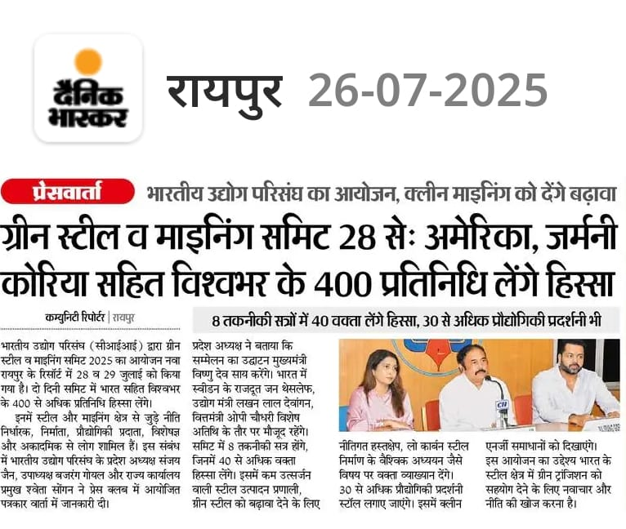

PUBLICATION | Navbharat | DATE | 26.07.2025
EDITION | Raipur | PAGE NO. | 02
ONLINE LINK | NA

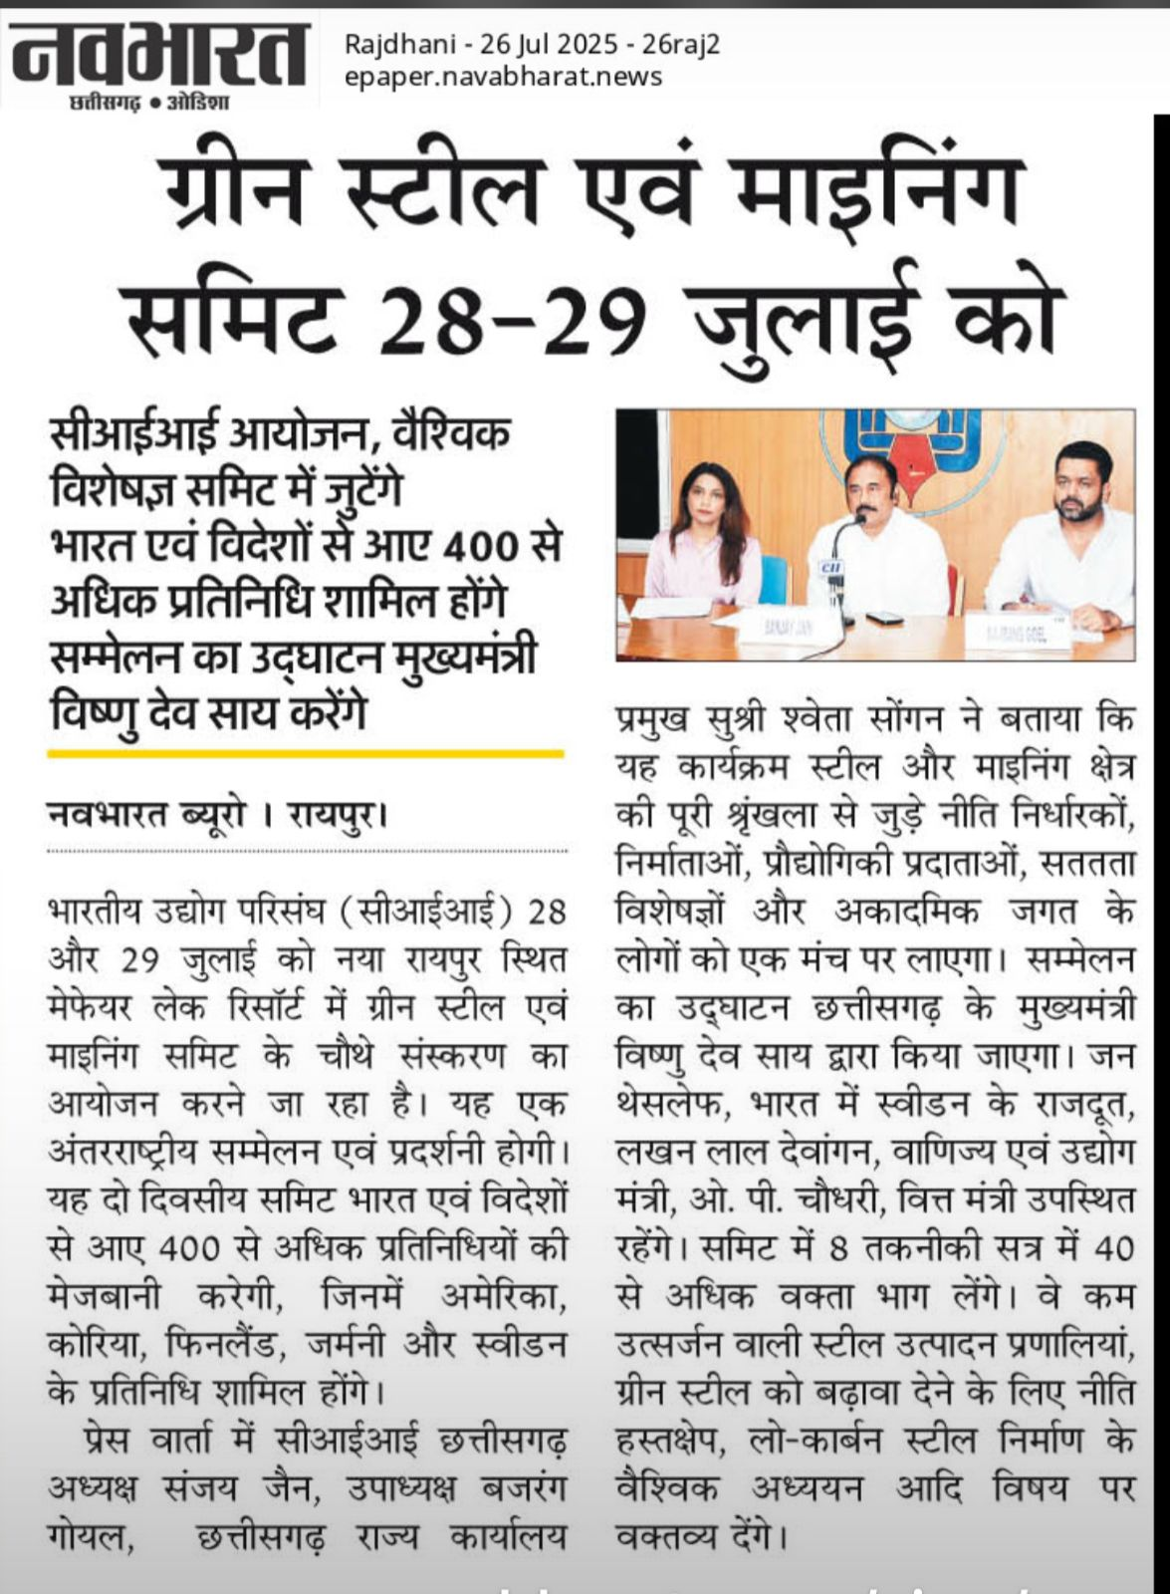

PUBLICATION | Haribhoomi | DATE | 26.07.2025
EDITION | Raipur | PAGE NO. | 07
ONLINE LINK | NA

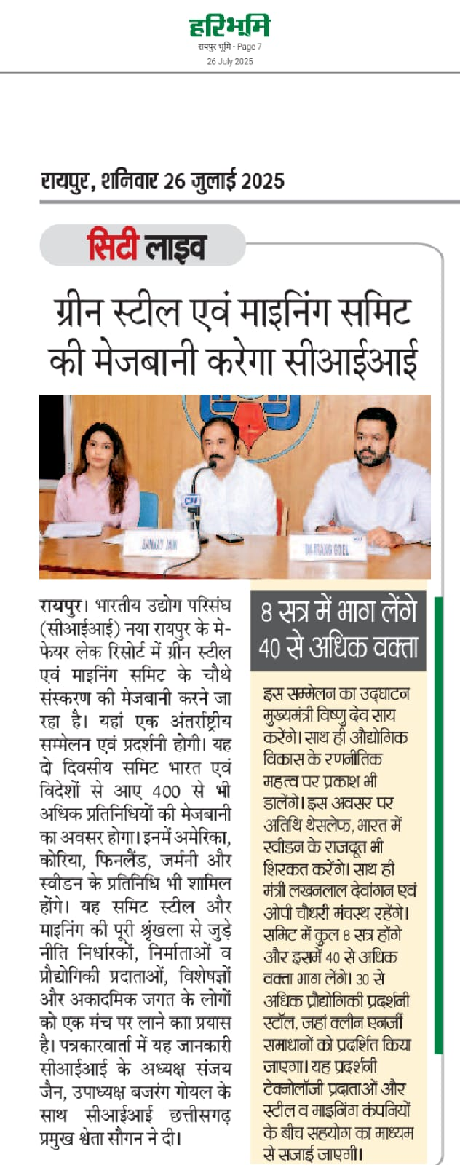

PUBLICATION | Naidunia | DATE | 26.07.2025
EDITION | Raipur | PAGE NO. | 3
ONLINE LINK | NA

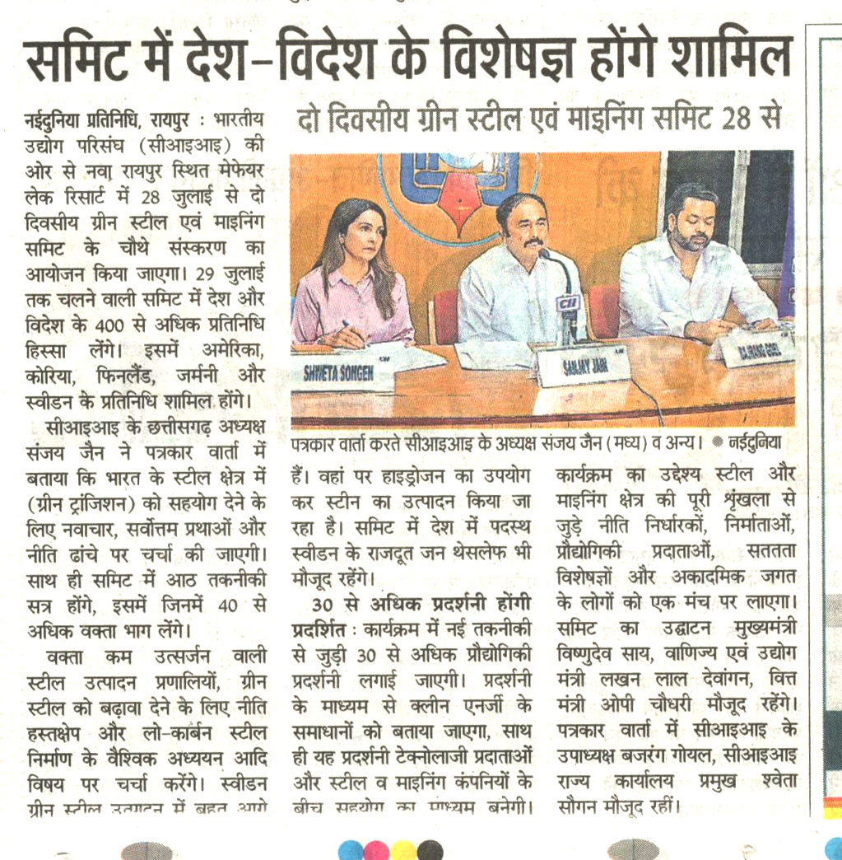

PUBLICATION | Central Chronicle | DATE | 26.07.2025
EDITION | Raipur | PAGE NO. | 05
ONLINE LINK | NA
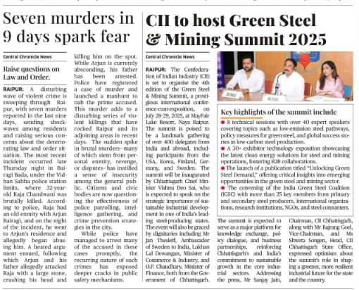

PUBLICATION | Hitavda | DATE | 26.07.2025
EDITION | Raipur | PAGE NO. | 04
ONLINE LINK | NA

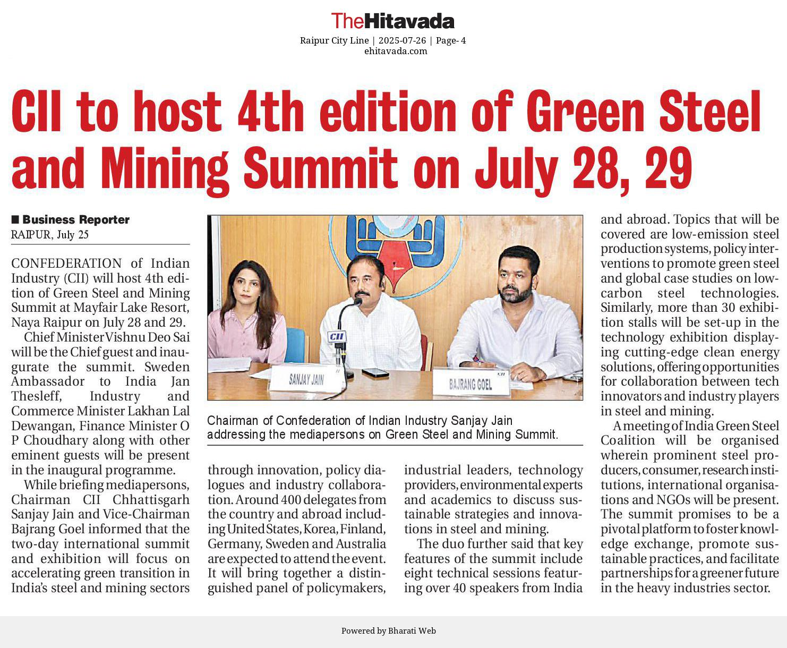

PUBLICATION | Amanpath | DATE | 26.07.2025
EDITION | Raipur | PAGE NO. | 12
ONLINE LINK | NA

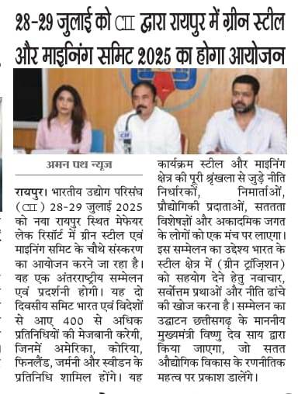

PUBLICATION | Swadesh | DATE | 26.07.2025
EDITION | Raipur | PAGE NO. | 03
ONLINE LINK | NA

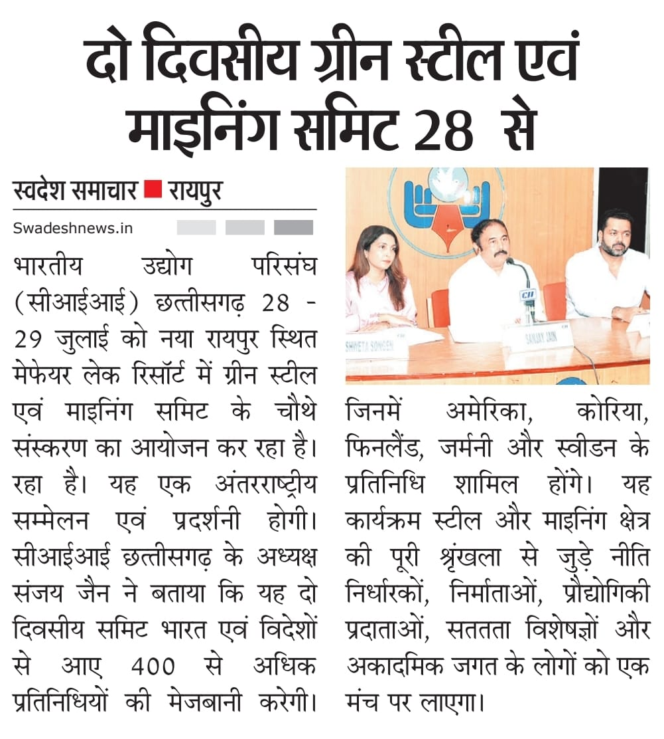

PUBLICATION | Lok Desh | DATE | 26.07.2025
EDITION | Raipur | PAGE NO. | 04
ONLINE LINK | NA

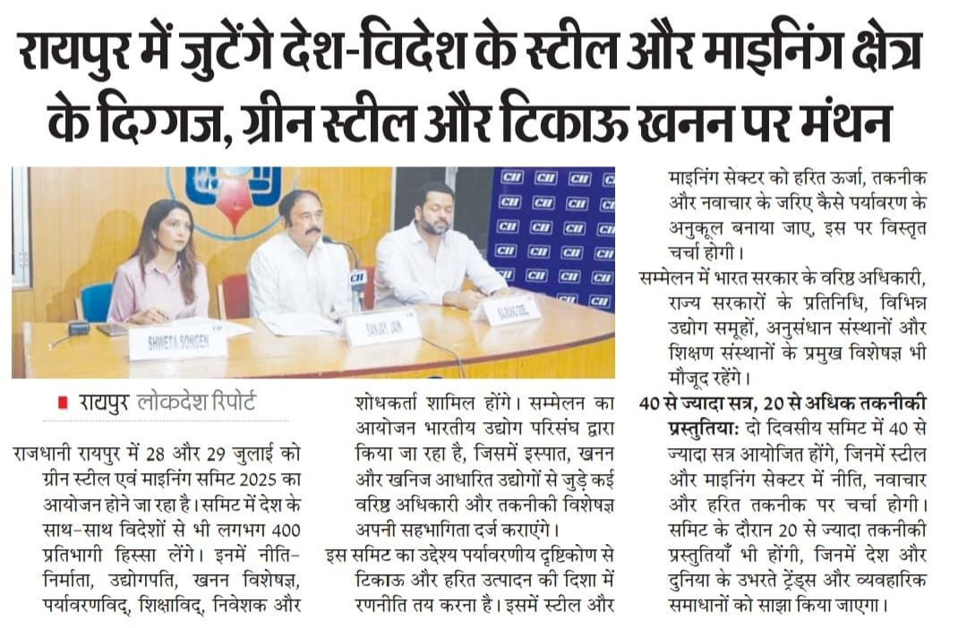

PUBLICATION | Vishwa Pariwar | DATE | 26.07.2025
EDITION | Raipur | PAGE NO. | 08
ONLINE LINK | NA

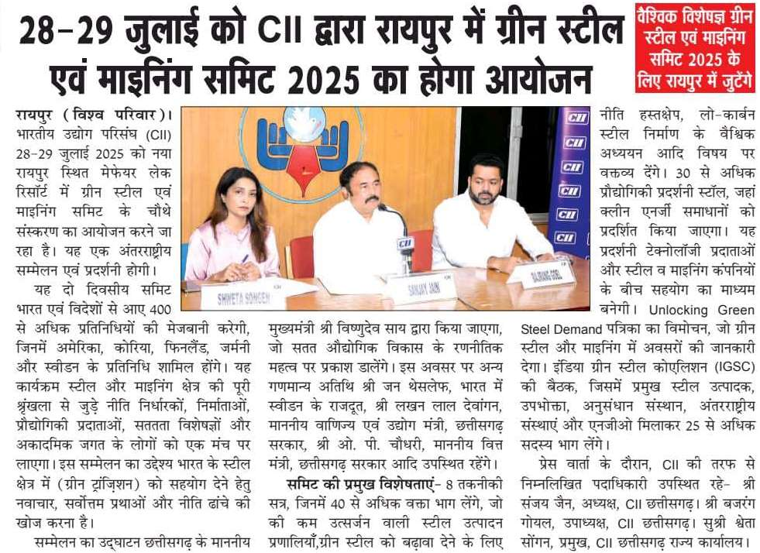

PUBLICATION | CG Watch | DATE | 26.07.2025
EDITION | Raipur | PAGE NO. | 07
ONLINE LINK | NA

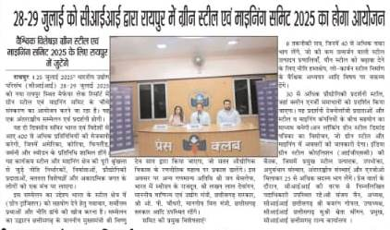

PUBLICATION | Amrit Sandesh | DATE | 26.07.2025
EDITION | Raipur | PAGE NO. | 02
ONLINE LINK | NA

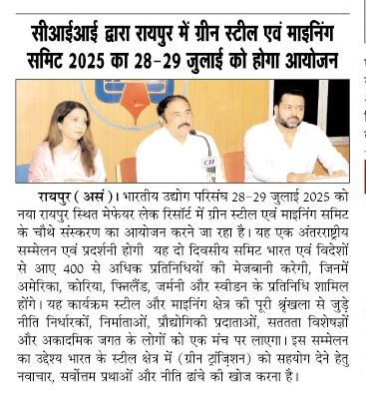

PUBLICATION | Chhattisgarh Sanv. | DATE | 25.07.2025
EDITION | Raipur | PAGE NO. | 10
ONLINE LINK | NA

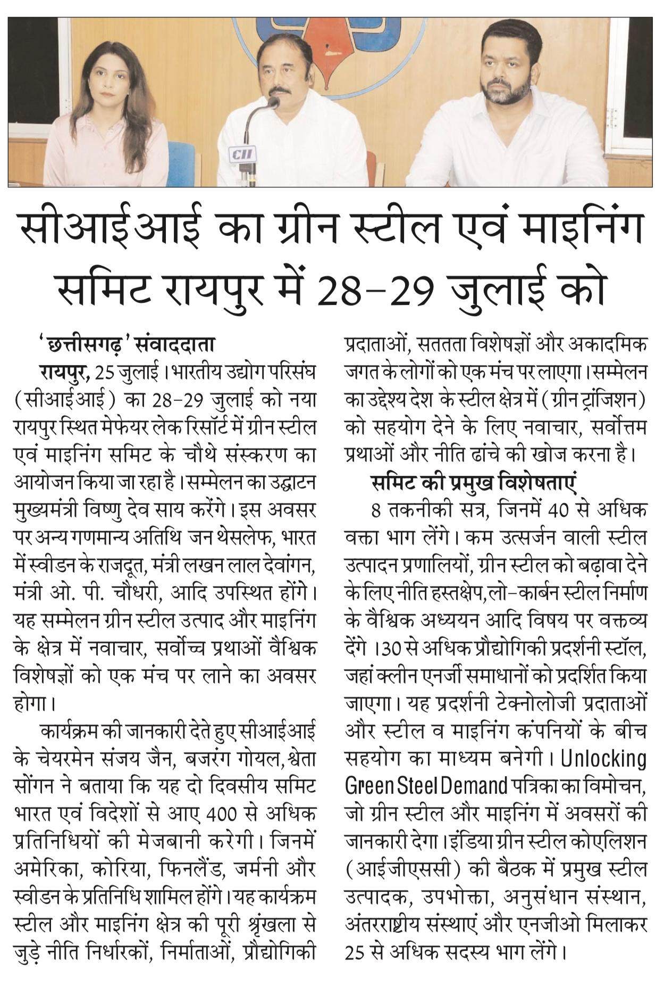

PUBLICATION | Aaj ka Alap | DATE | 26.07.2025
EDITION | Raipur | PAGE NO. | 03
ONLINE LINK | NA

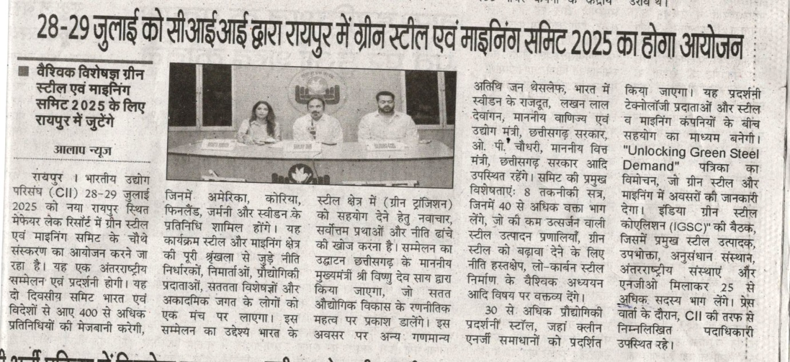

PUBLICATION | Aaj ki Jandhara | DATE | 26.07.2025
EDITION | Raipur | PAGE NO. | 3
ONLINE LINK | NA

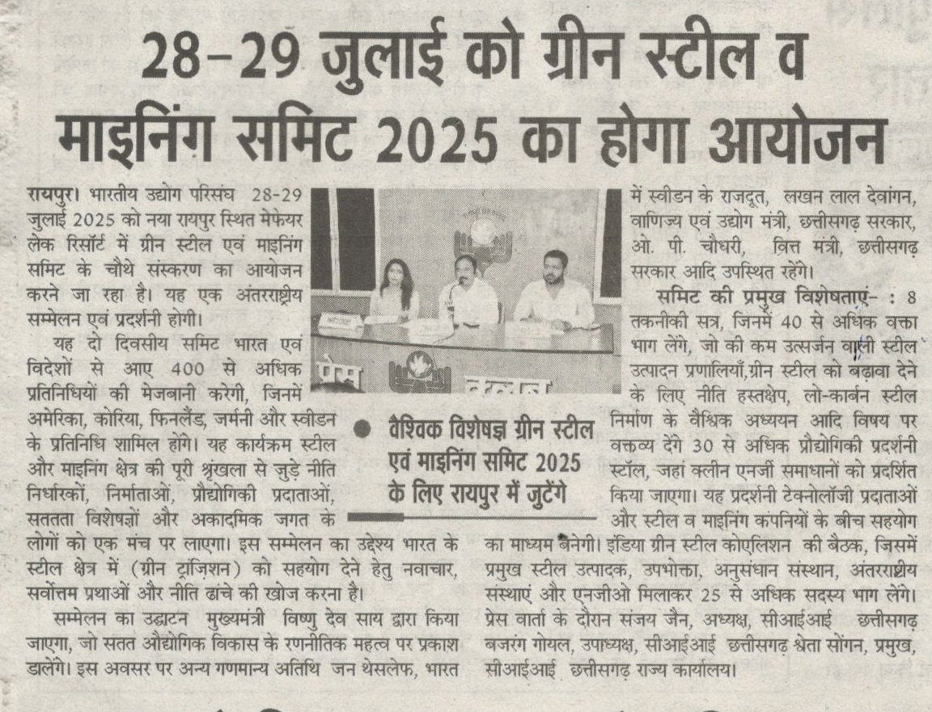

PUBLICATION | Aman path | DATE | 26.07.2025
EDITION | Raipur | PAGE NO. | 12
ONLINE LINK | NA

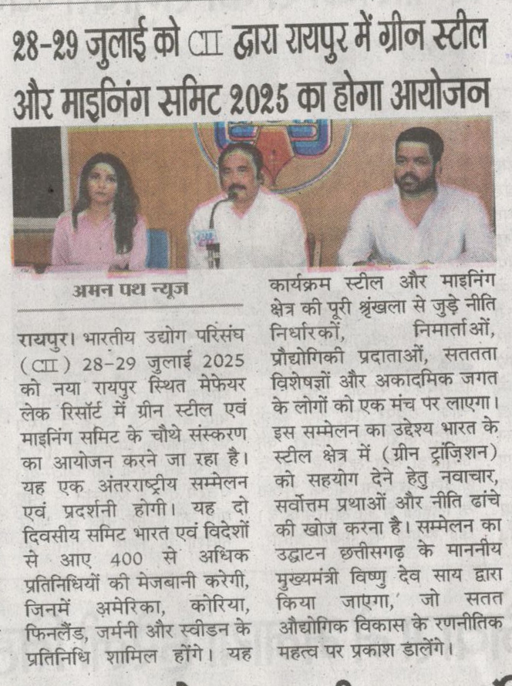

PUBLICATION | Deshbandhu | DATE | 26.07.2025
EDITION | Raipur | PAGE NO. | 4
ONLINE LINK | NA

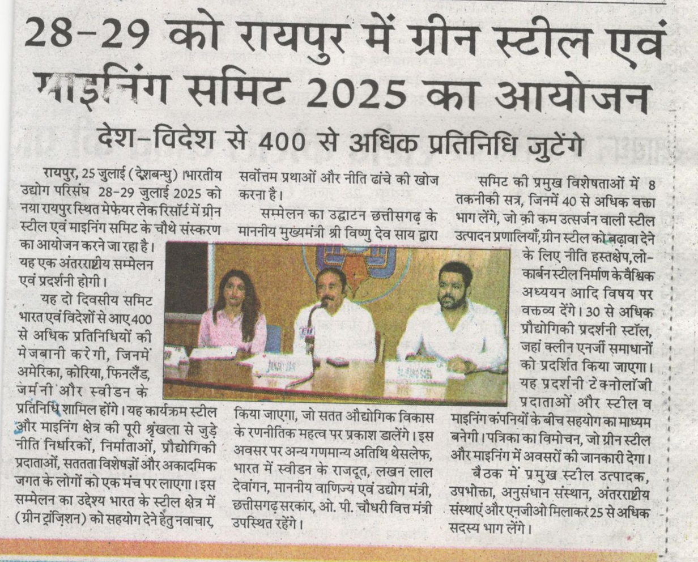

PUBLICATION | Kuber bhoomi | DATE | 26.07.2025
EDITION | Raipur | PAGE NO. | Back page (08)
ONLINE LINK | NA

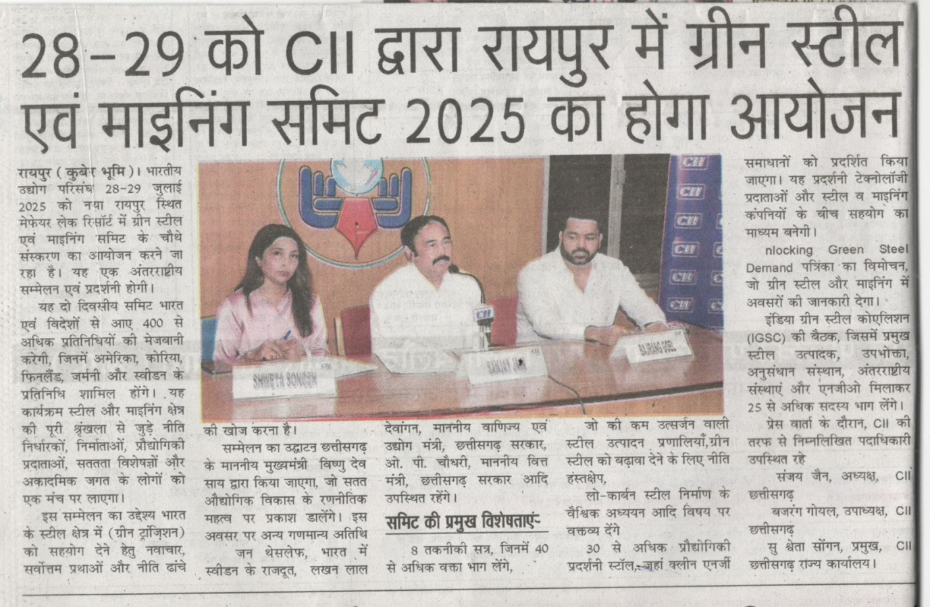

PUBLICATION | Pioneer Hindi | DATE | 26.07.2025
EDITION | Raipur | PAGE NO. | 9
ONLINE LINK | NA

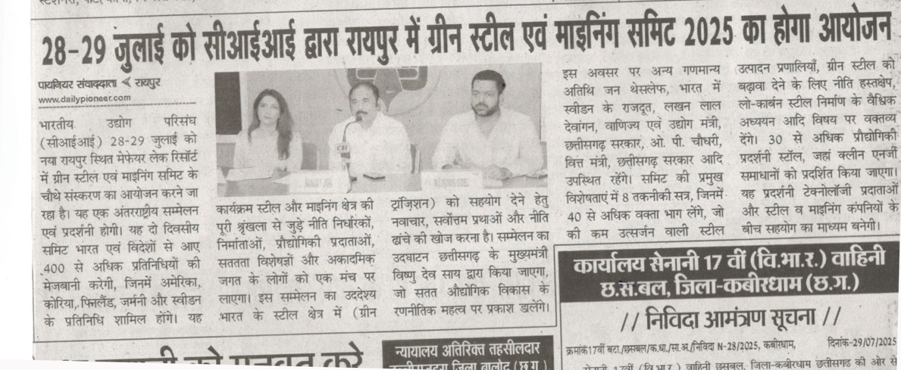

PUBLICATION | Pratidin Rajdhani | DATE | 26.07.2025
EDITION | Raipur | PAGE NO. | 12
ONLINE LINK | NA

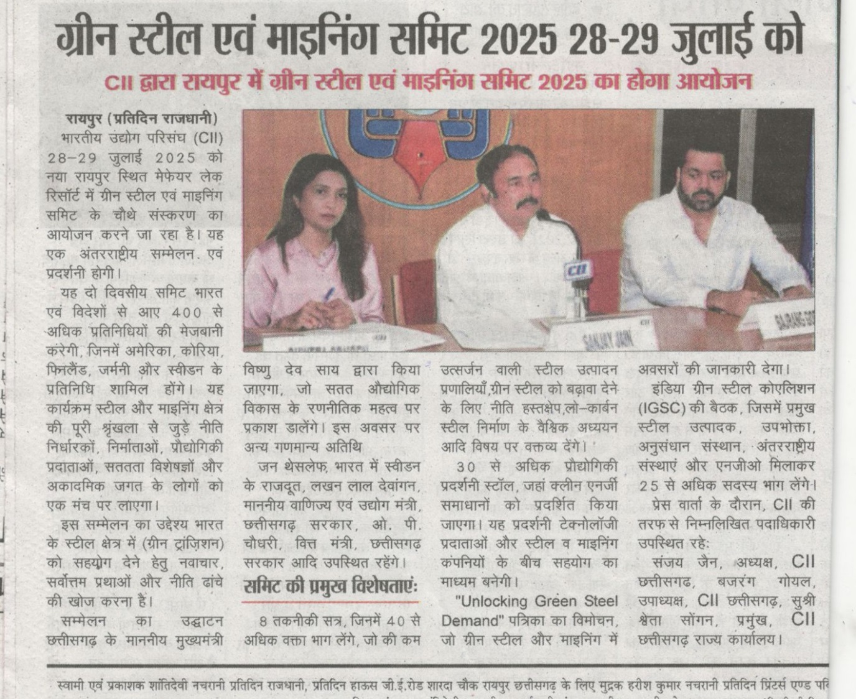

PUBLICATION | Media 24 News | DATE | 26.07.2025
EDITION | Online | PAGE NO.
ONLINE LINK | https://media24news.in/?p=87167

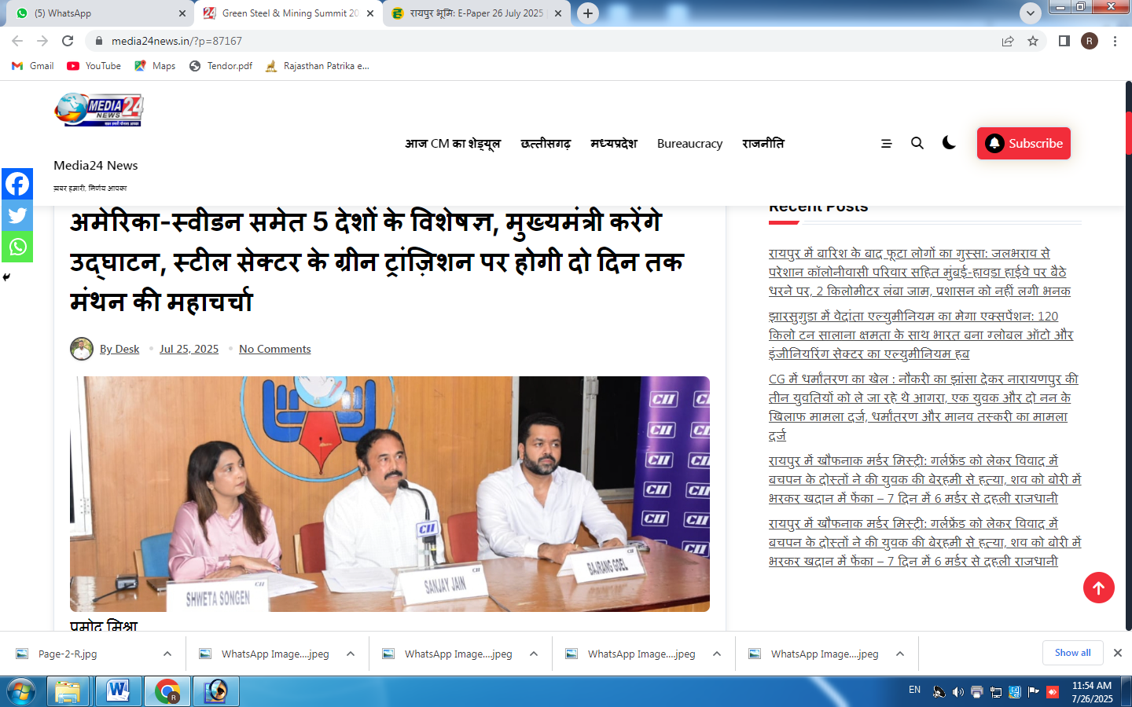

PUBLICATION | Ekhabari.com | DATE | 26.07.2025
EDITION | Online | PAGE NO.
ONLINE LINK | https://ekhabri.com/green-steel-and-mining-summit-2025-to-be-held-in-raipur-from-july-28/

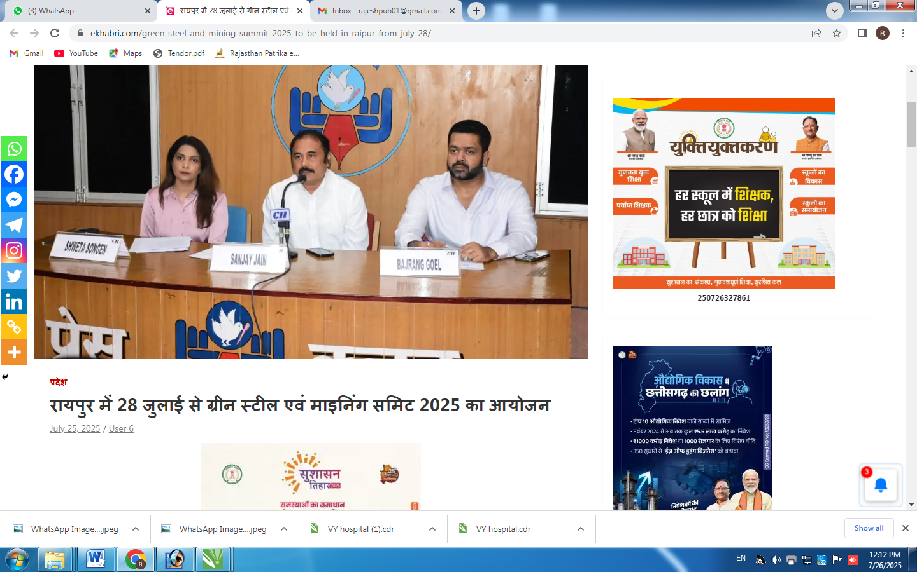

PUBLICATION | Sansanicg.in | DATE | 26.07.2025
EDITION | Online | PAGE NO.
ONLINE LINK | https://sansanicg.in/raipur-25-july-2025-confederation-of-indian-industry-cii-will-be-organizing-a-function-at-mayfair-lake-resort-naya-raipur-on-28-29-july-2025/

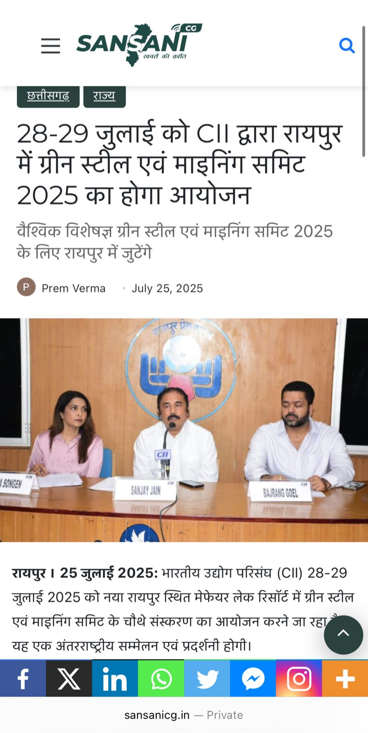

PUBLICATION | Dainik CG watch | DATE | 26.07.2025
EDITION | Online | PAGE NO.
ONLINE LINK | https://dainikchhattisgarhwatch.com/2025/07/25/jjgreen-steel-and-mining-summit-2025-to-be-organised-by-cia-in-raipur-on-28-29-july/

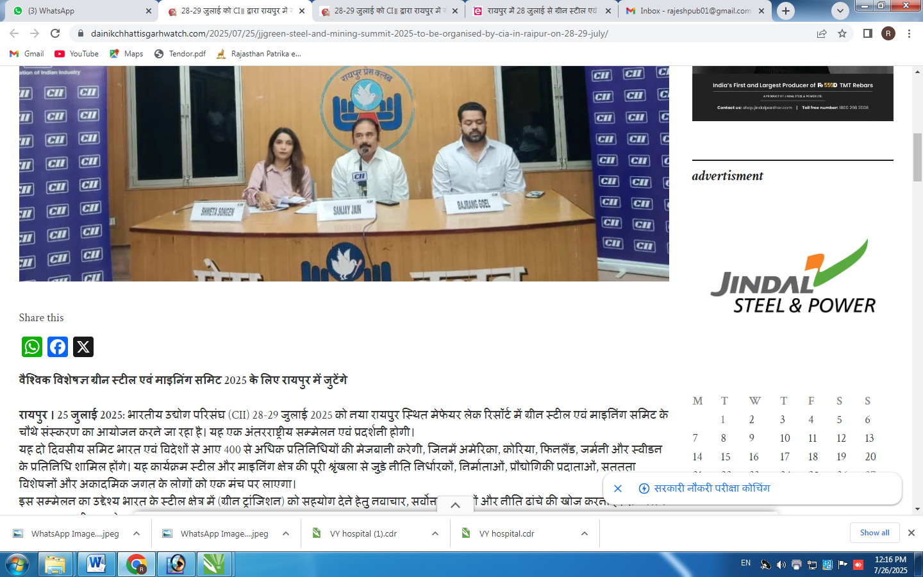

PUBLICATION | Dainik Chhattisgarh | DATE | 26.07.2025
EDITION | Online | PAGE NO.
ONLINE LINK | https://dainikchhattisgarh.com/2025/07/25/raipur-25-july-2025-confederation-of-indian-industry-cii-will-be-organizing-a-function-at-mayfair-lake-resort-naya-raipur-on-28-29-july-2025/

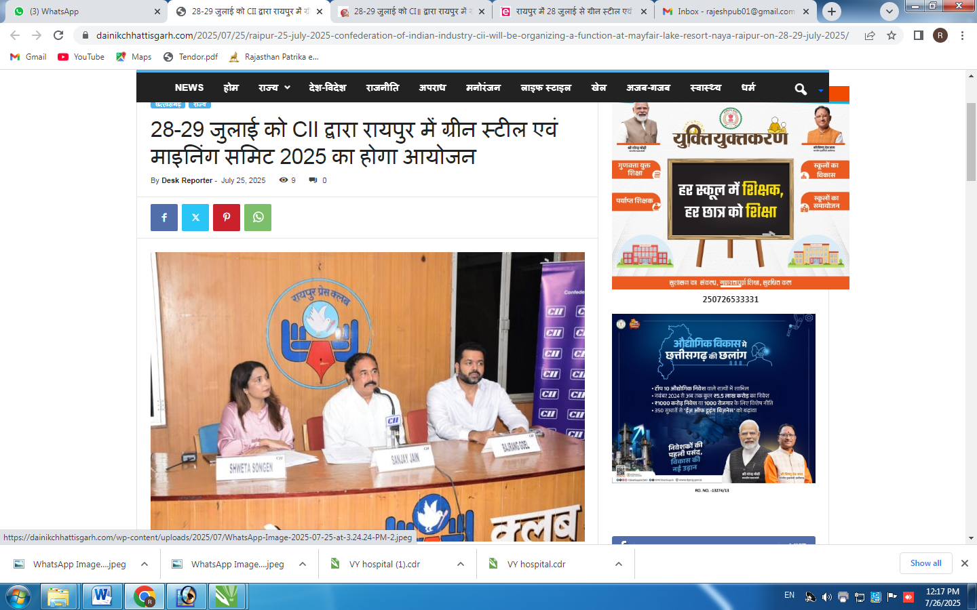

PUBLICATION | Shubhupkar.com | DATE | 26.07.2025
EDITION | Online | PAGE NO.
ONLINE LINK | https://www.shubhupkar.com/2025/07/raipur-2829-2025-cii.html

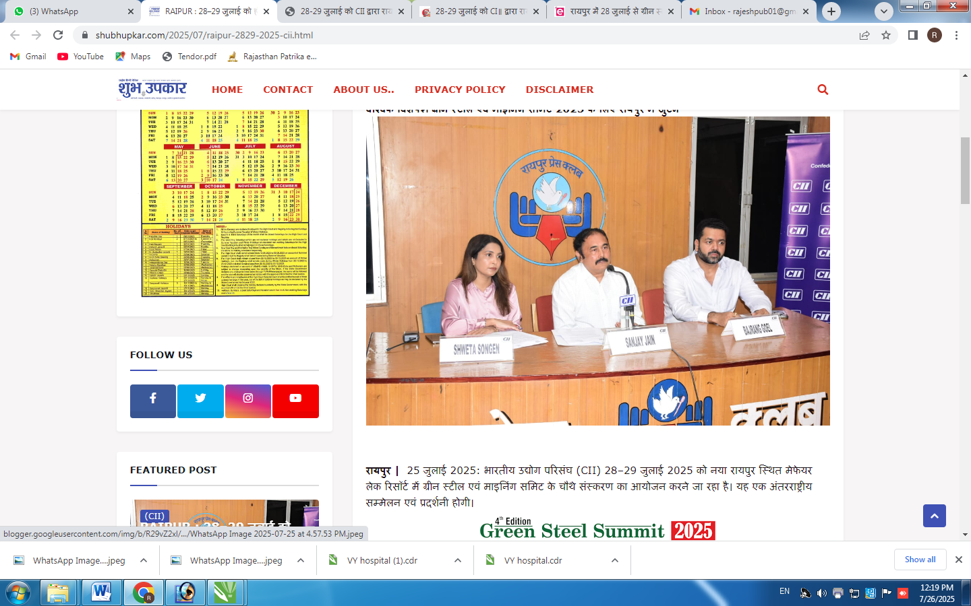

PUBLICATION | dainikchhattisgarh.com | DATE | 26.07.2025
EDITION | Online | PAGE NO.
ONLINE LINK | https://dainikchhattisgarh.com/2025/07/25/raipur-25-july-2025-confederation-of-indian-industry-cii-will-be-organizing-a-function-at-mayfair-lake-resort-naya-raipur-on-28-29-july-2025/
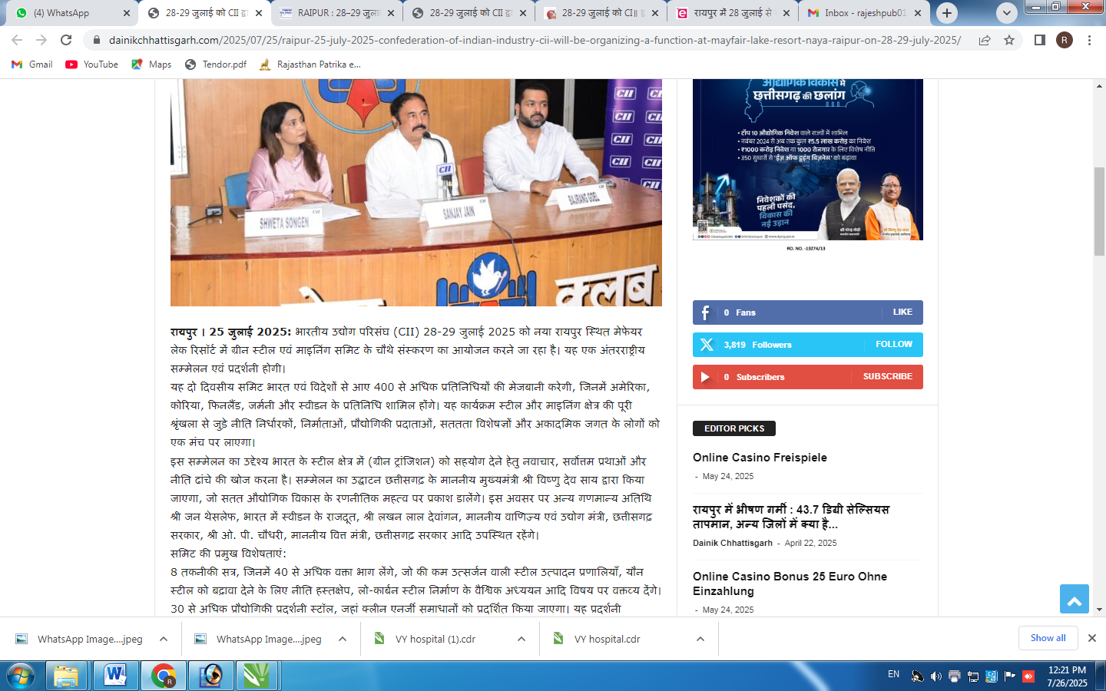

PUBLICATION | newsvibe.in | DATE | 26.07.2025
EDITION | Online | PAGE NO.
ONLINE LINK | https://newsvibe.in/green-steel-and-mining-summit-2025-will-be-organized-by-cii-on-28-july-28-28-july/

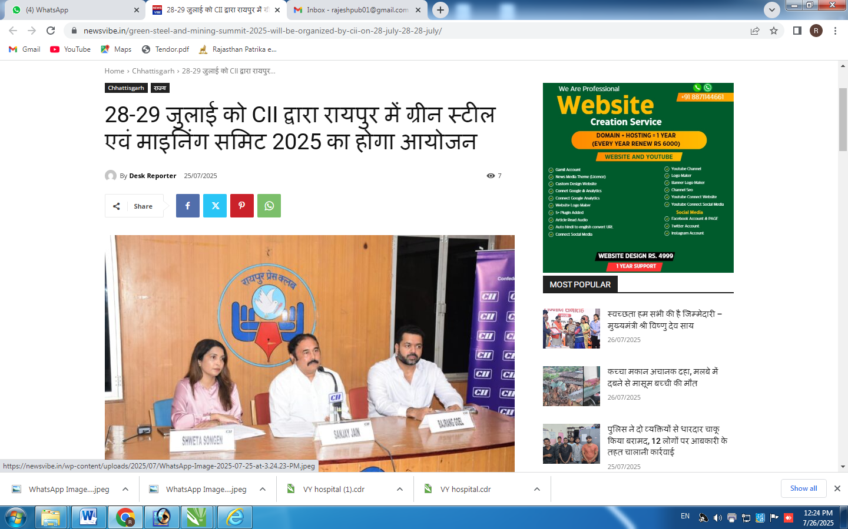

PUBLICATION | Apnisarkaar.com | DATE | 26.07.2025
EDITION | Online | PAGE NO.
ONLINE LINK | https://apnisarkaar.com/green-steel-and-mining-summit-2025-to-be-organised-by-cii-in-raipur-on-28-29-july/
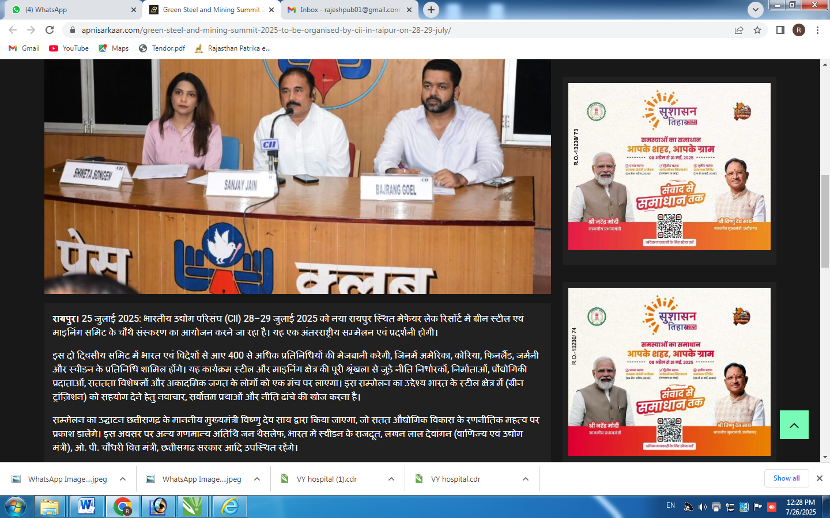

PUBLICATION | themorningtimes.in | DATE | 26.07.2025
EDITION | Online | PAGE NO.
ONLINE LINK | https://themorningtimes.in/raipur-25-july-2025-confederation-of-indian-industry-cii-will-be-organizing-a-function-at-mayfair-lake-resort-naya-raipur-on-28-29-july-2025/

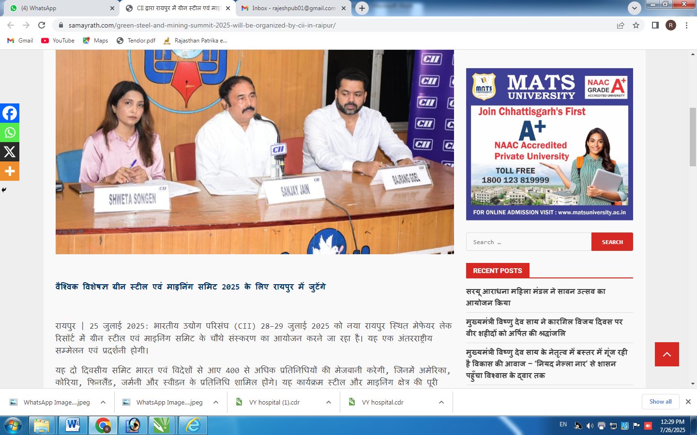

PUBLICATION | samayrath.com | DATE | 26.07.2025
EDITION | Online | PAGE NO.
ONLINE LINK | https://samayrath.com/green-steel-and-mining-summit-2025-will-be-organized-by-cii-in-raipur/

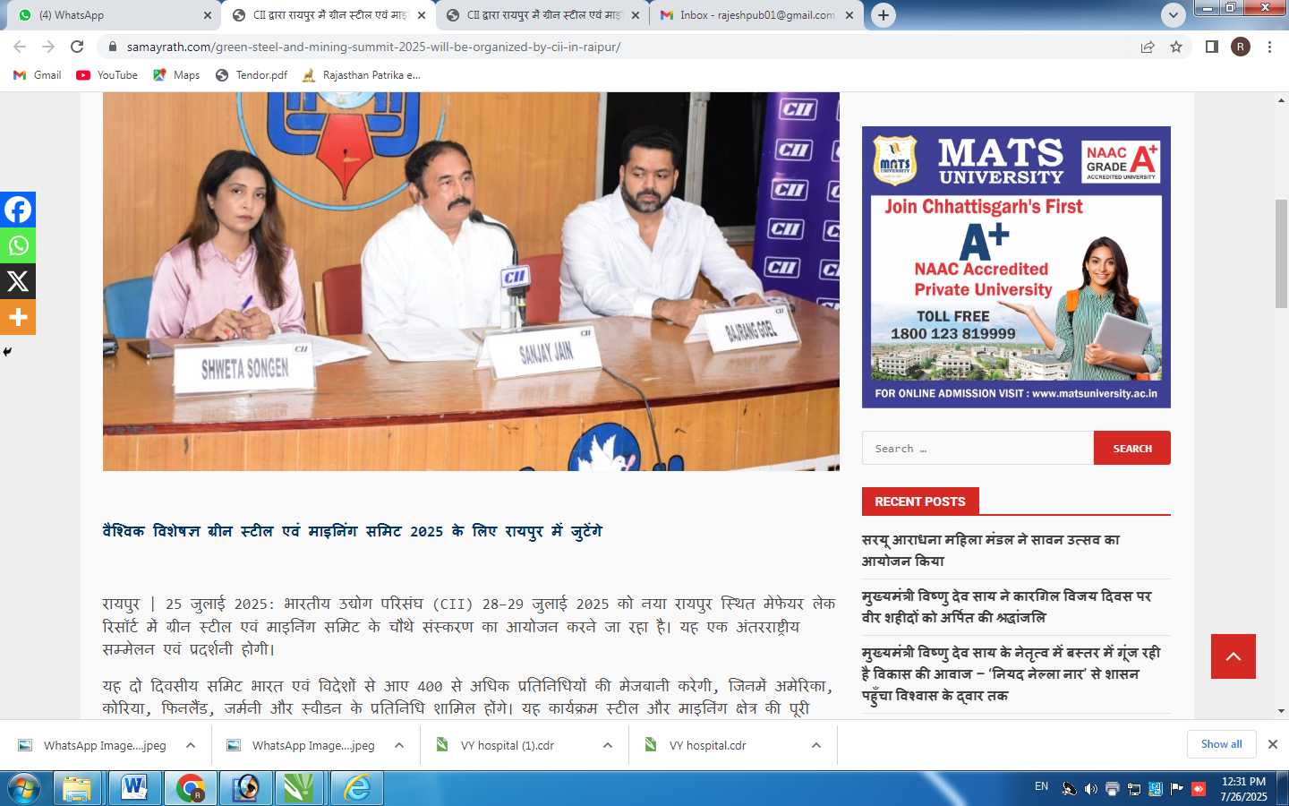

PUBLICATION | amrittimes.com | DATE | 26.07.2025
EDITION | Online | PAGE NO.
ONLINE LINK | https://amrittimes.com/green-steel-and-mining-summit-2025green-steel-and-mining-summit-2025-to-be-organized-by-cii-in-raipur-on-2829-july/

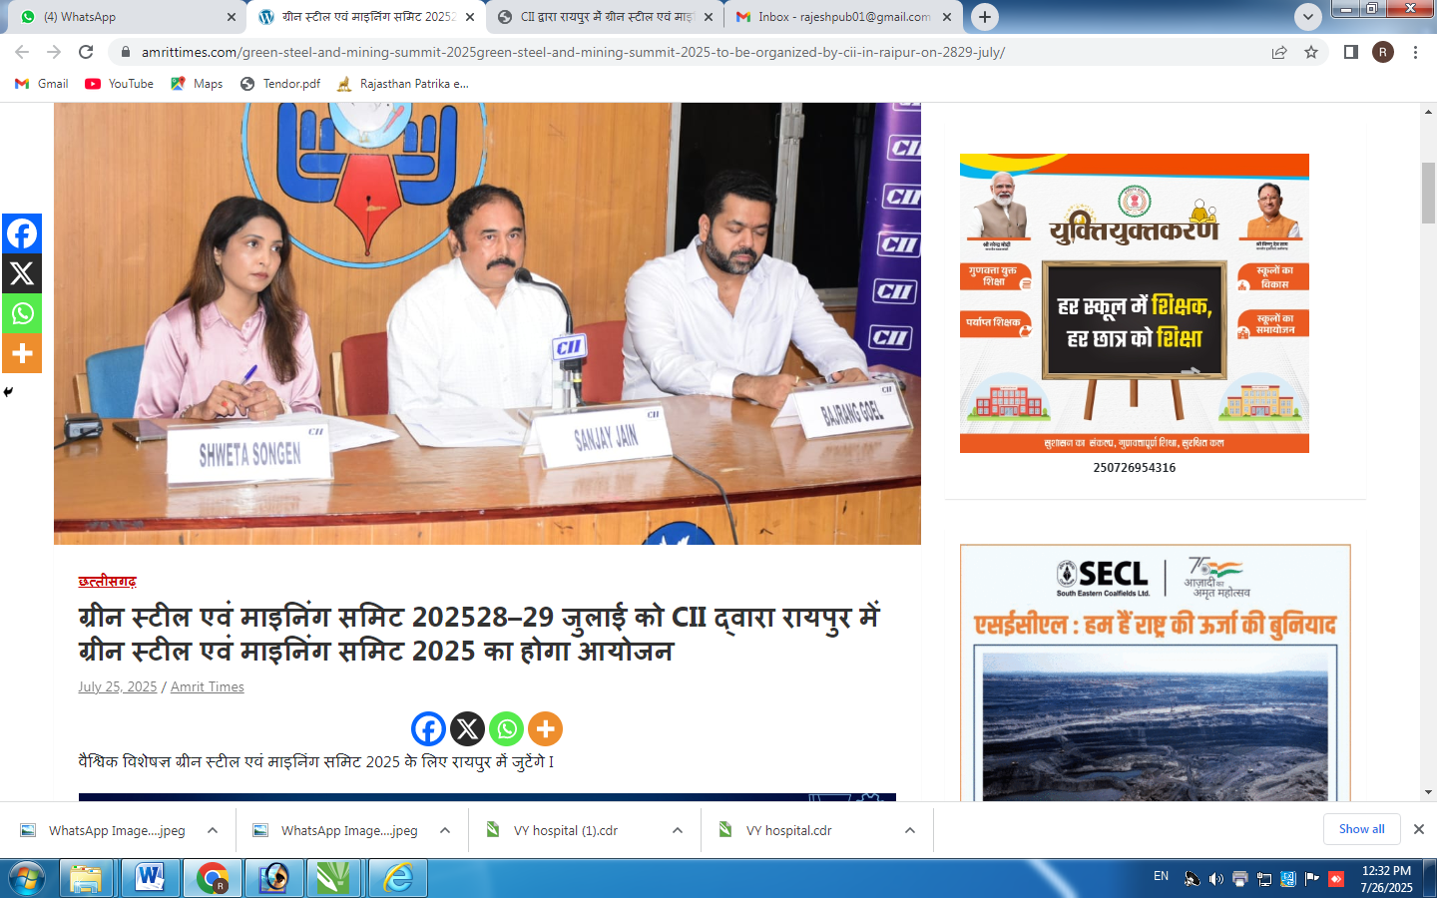

PUBLICATION | misaal.news | DATE | 26.07.2025
EDITION | Online | PAGE NO.
ONLINE LINK | https://misaal.news/8287/ciis-green-steel-and-mining-summit-will-inaugurate-chief-minister-in-naya-raipur-on-28-and-29-july/

